Configuracion S4 para Service V2:

1.- Ejecutar el wizard a través del reporte: RCOD_CREATE_CONNECTIVITY_V2:

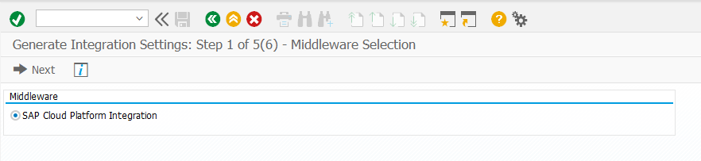

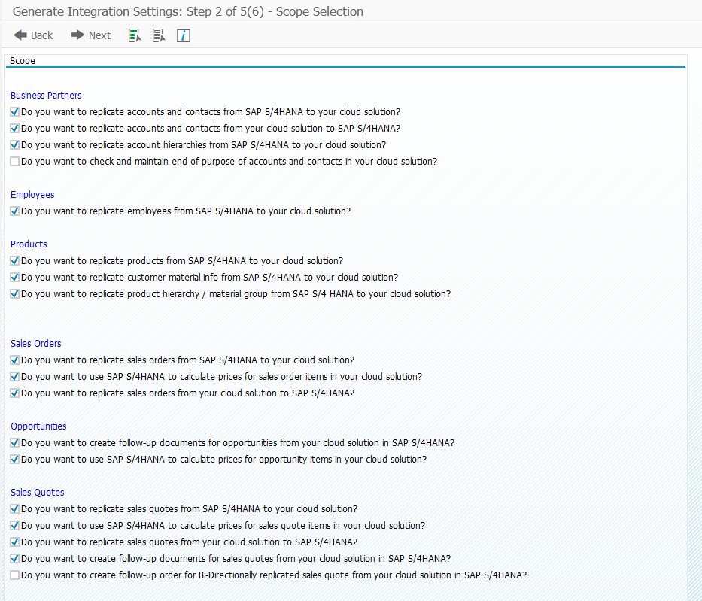

Aquí debemos crear el sistema lógico del service 2. En esta versión ya no tiene 6 digitos por lo que hay que seguir la nota: <https://userapps.support.sap.com/sap/support/knowledge/en/3417215>

En este caso el id del service 2 es: sap_cloud_crm_my1001792, por lo que el sist lógico se debe crear con el id “1001792”:

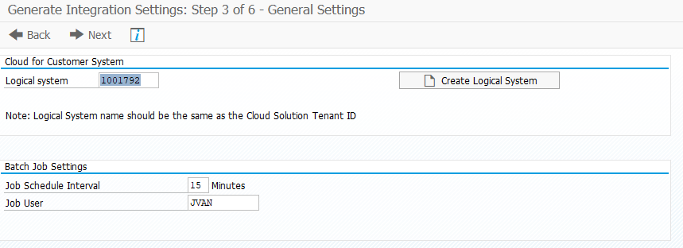

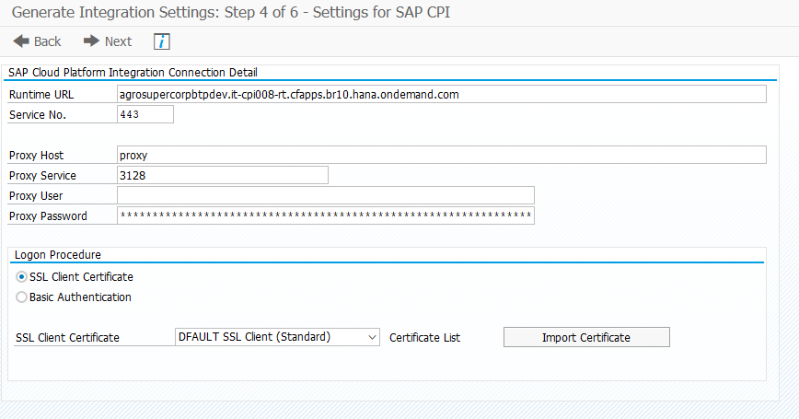

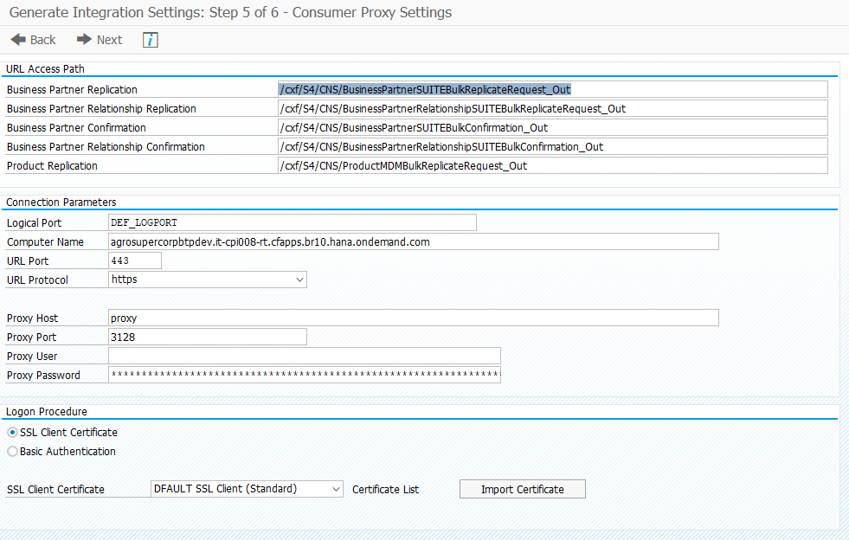

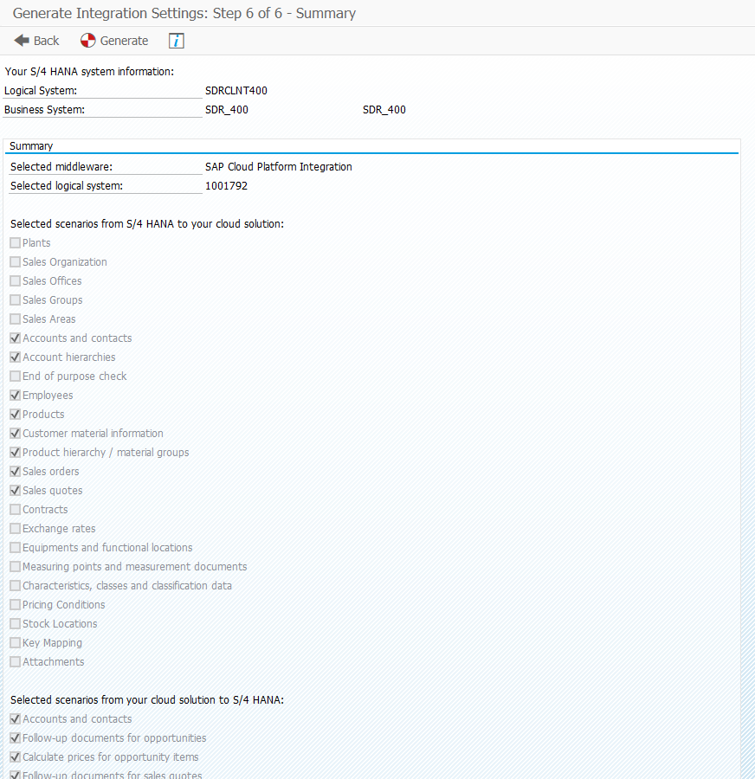

Finalmente se crea la configuración:

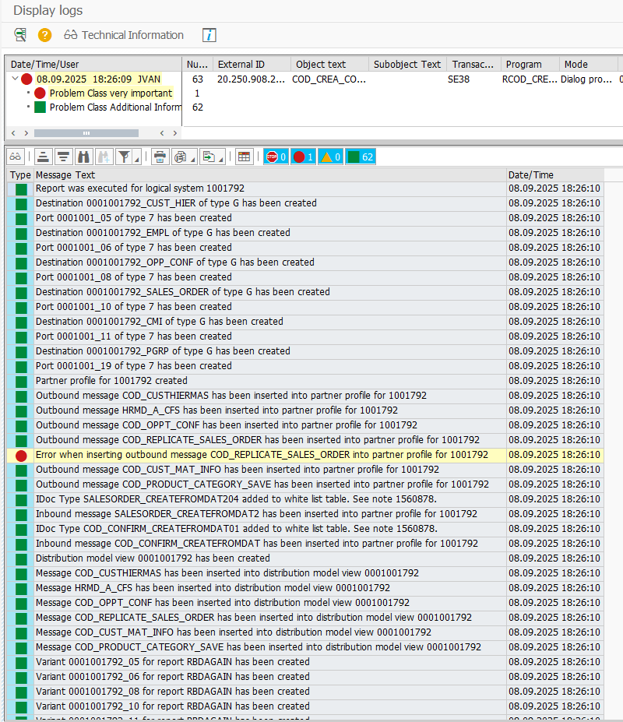

Si revisamos la WE20 nos muestra la config en cuanto a IDOCS:

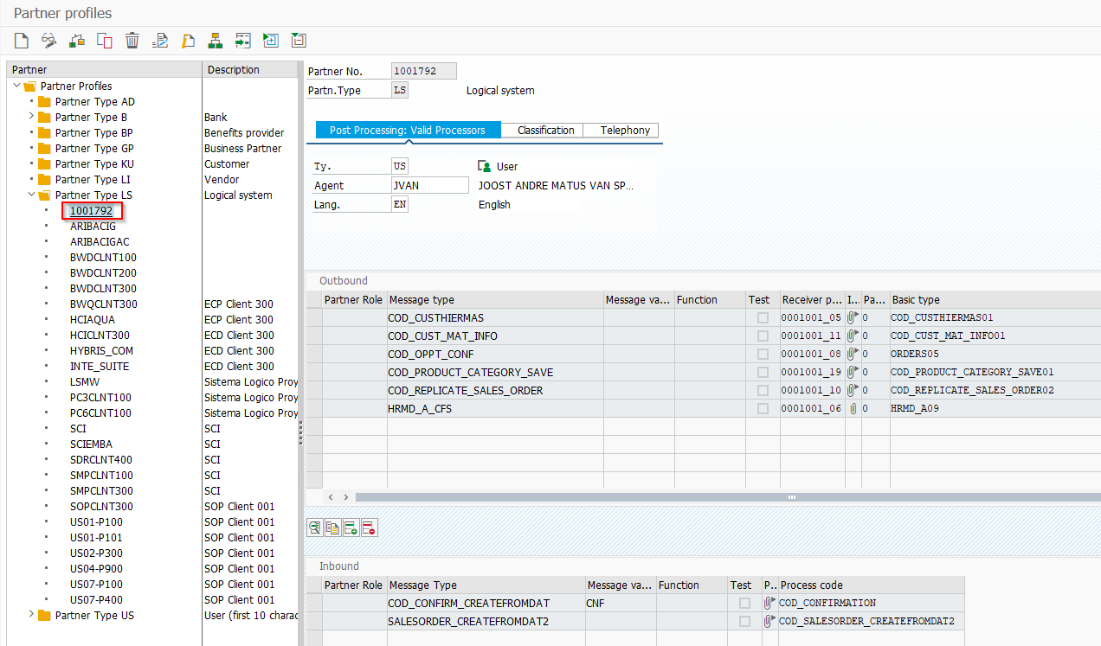

Y si vamos a la SOAMANAGER y buscamos los service consumer de BP (CO_MDG_BP_RPLCTRQ,

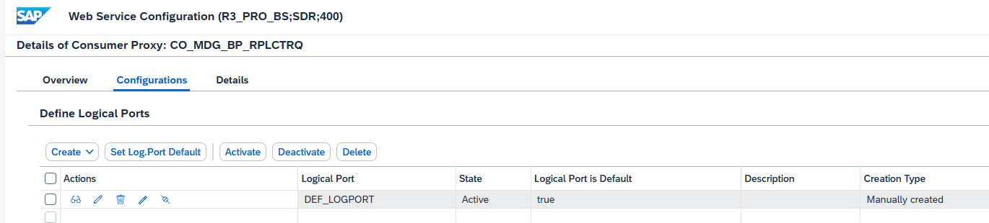

*NOTA: Solo se crean algunos en soamanager, el resto como la replicación de sales organization (CO_SDMD_ESR_SALES_ORGANIZATION), etc se deben hacer a mano.

2.- Ahora se debe configurar el modelo de replicación en trx DRFIMF:

a) Crear Business system (Este paso se debe hacer por mandante):

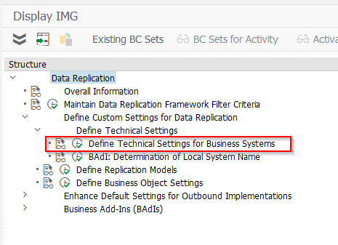

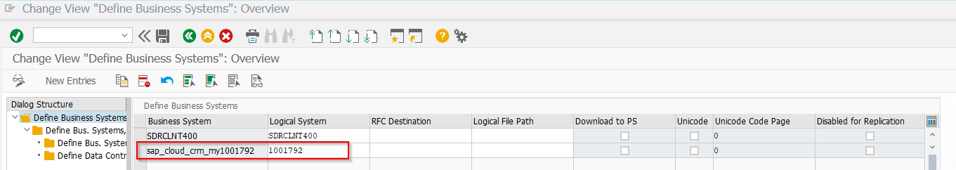

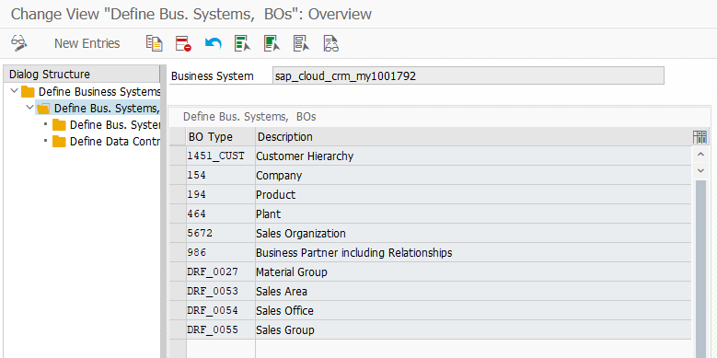

b) Crear modelo de replicación (Este paso se puede guardar en OT para luego transportar):

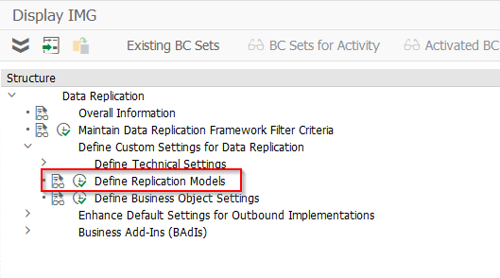

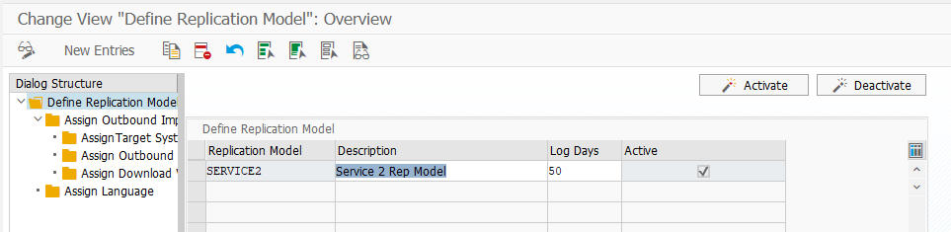

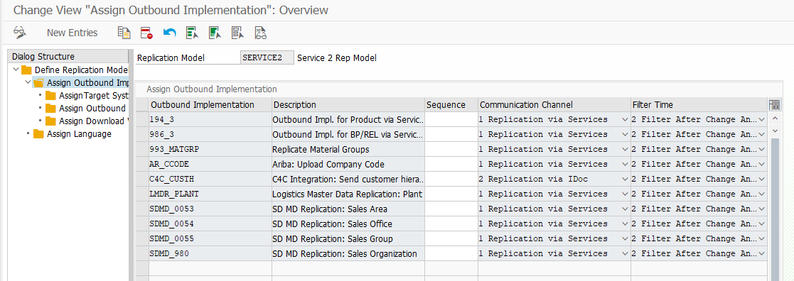

3) Configuración de envio de codelists:

a) Para los codelist, los siguientes iflows utilizan Odata:

|  |
| --- |
| Replicate Payment Terms from SAP S/4HANA |
| Replicate Unit Of Measure from SAP S/4HANA |
| Replicate Company Legal Form from SAP S/4HANA |
| Replicate Delivery Priority from SAP S/4HANA |
| Replicate Price Specification Customer Group from SAP S/4HANA |
| Replicate Industrial Sector from SAP S/4HANA |
| Replicate Customer Price List Type from SAP S/4HANA |
| Replicate Customer Group from SAP S/4HANA |
| Replicate Invoicing Blocking Reason from SAP S/4HANA |
| Replicate Delivery Blocking Reason from SAP S/4HANA |
| Replicate Cash Discount Terms from SAP S/4HANA |
| Replicate Department from SAP S/4HANA |
| Replicate Functional Title from SAP S/4HANA |
| Replicate Distribution Channel from SAP S/4HANA |
| Replicate Division from SAP S/4HANA |

Replicate Region Codes from SAP S4HANA

Replicate Product Type from SAP S4HANA

Por lo que se debe publicar el servicio Odata:

1. Open transaction

|  |  |
| --- | --- |
| Field Name | Entry Value |
| Transaction Code | /n/IWFND/V4_ADMIN |
| Navigation | SPRO > ABAP Platform > SAP Gateway > OData Channel > Administration > General Settings for OData V4 > OData V4 Service Administration |

1. Choose Publish Service Group button .
2. Enter System Alias as LOCAL.
3. Enter Service Group ID <SERVICE_NAME_FROM_TABLE_BELOW >.

|  |
| --- |
| Service Group Name |
| CDI_CDS |

1. Select Get Service Groups. Service group with the name entered in previous step will appear on the list if it is unpublished.

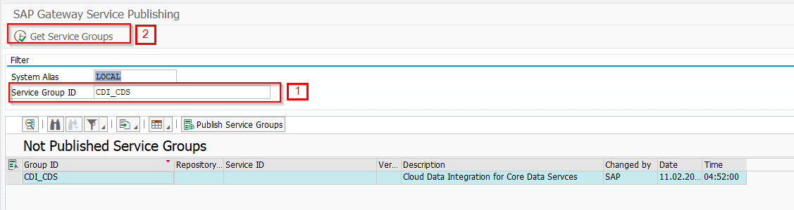

1. Select the service.
2. Choose Publish Service Groups
3. Click Continue button or click Enter on your keyboard.
4. Select or create transport request if needed.
5. Infornation message with text “New service group(s) successfully published” will appear.